Task 1: Squares of a Sorted Array
Program:
import java.util.Arrays;
public class SquaresOfSortedArray {
public static void main(String[] args) {
int[] nums = {-4, -1, 0, 3, 10};
int[] result = sortedSquares(nums);
System.out.println(Arrays.toString(result));
}
static int[] sortedSquares(int[] nums) {
int n = nums.length;
int[] res = new int[n];
int l = 0, r = n - 1, k = n - 1;
while (l <= r) {
if (nums[l] * nums[l] > nums[r] * nums[r]) {
res[k--] = nums[l] * nums[l];
l++;
} else {
res[k--] = nums[r] * nums[r];
r--;
}
}
return res;
}
}
Output:
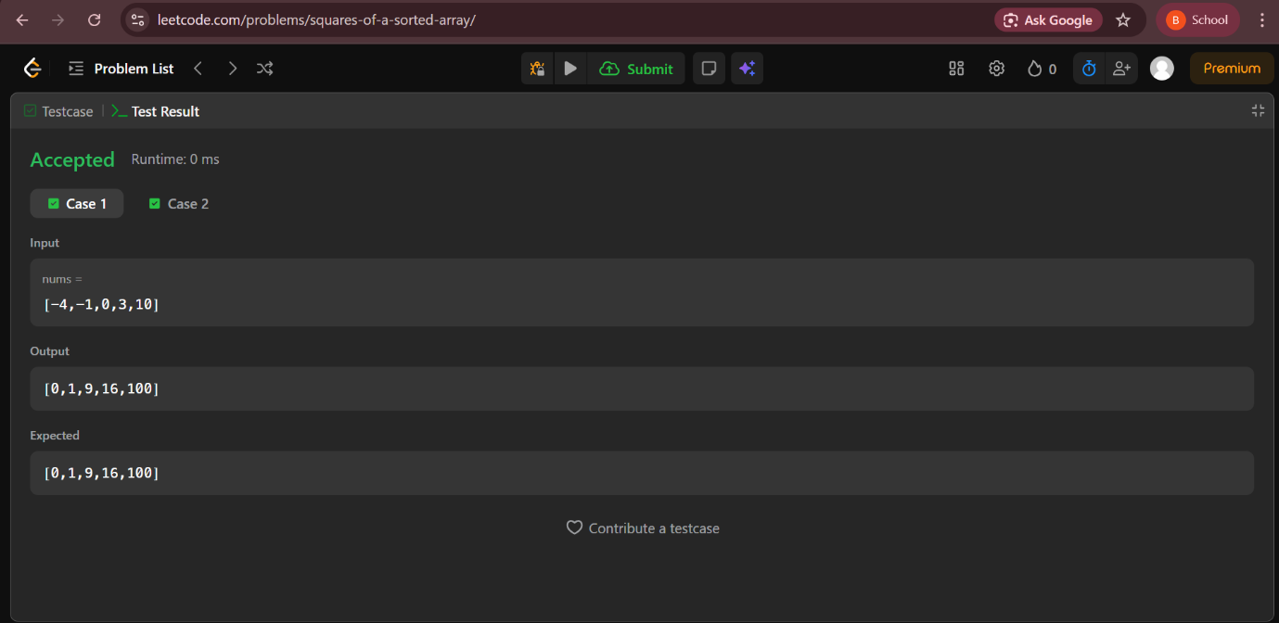
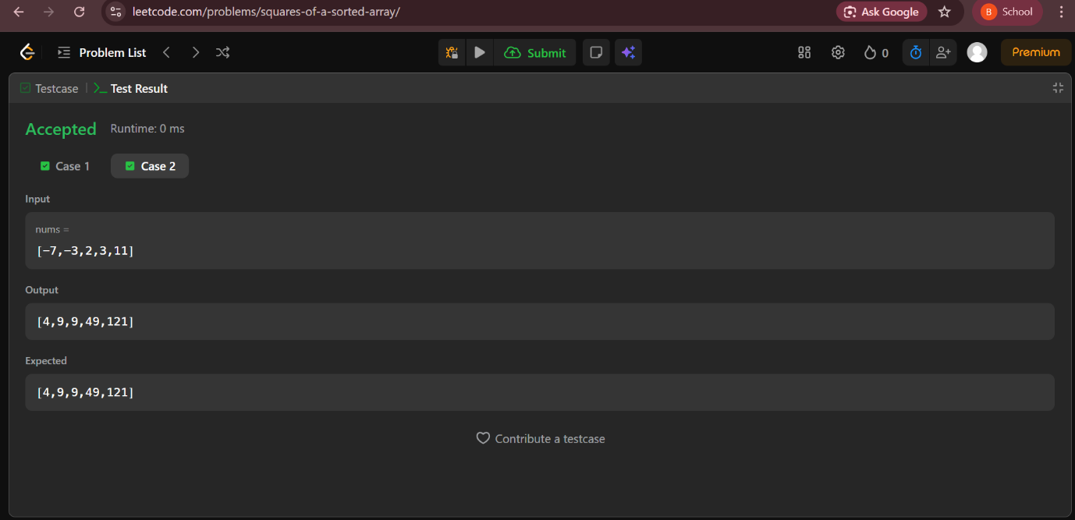

Task 2: Contains Duplicate II
Program:
import java.util.HashMap;
public class ContainsDuplicateII {
public static void main(String[] args) {
int[] nums = {1, 2, 3, 1};
int k = 3;
System.out.println(containsNearbyDuplicate(nums, k));
}
static boolean containsNearbyDuplicate(int[] nums, int k) {
HashMap<Integer, Integer> map = new HashMap<>();
for (int i = 0; i < nums.length; i++) {
if (map.containsKey(nums[i]) && i - map.get(nums[i]) <= k)
return true;
map.put(nums[i], i);
}
return false;
}
}

Output:
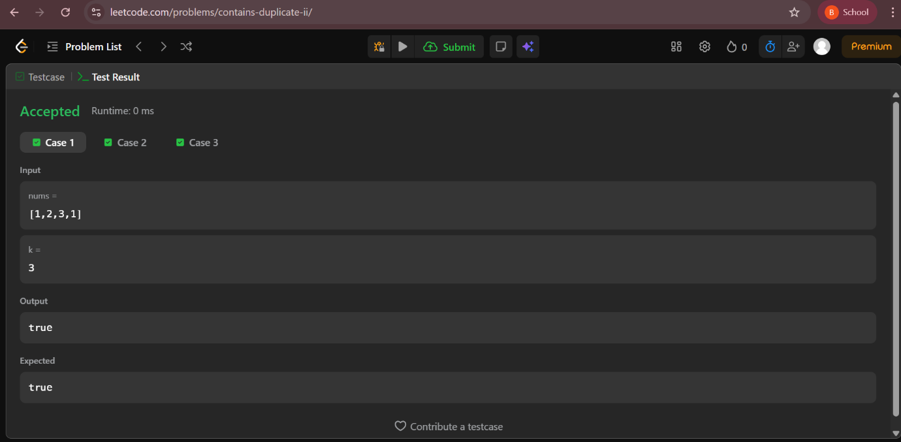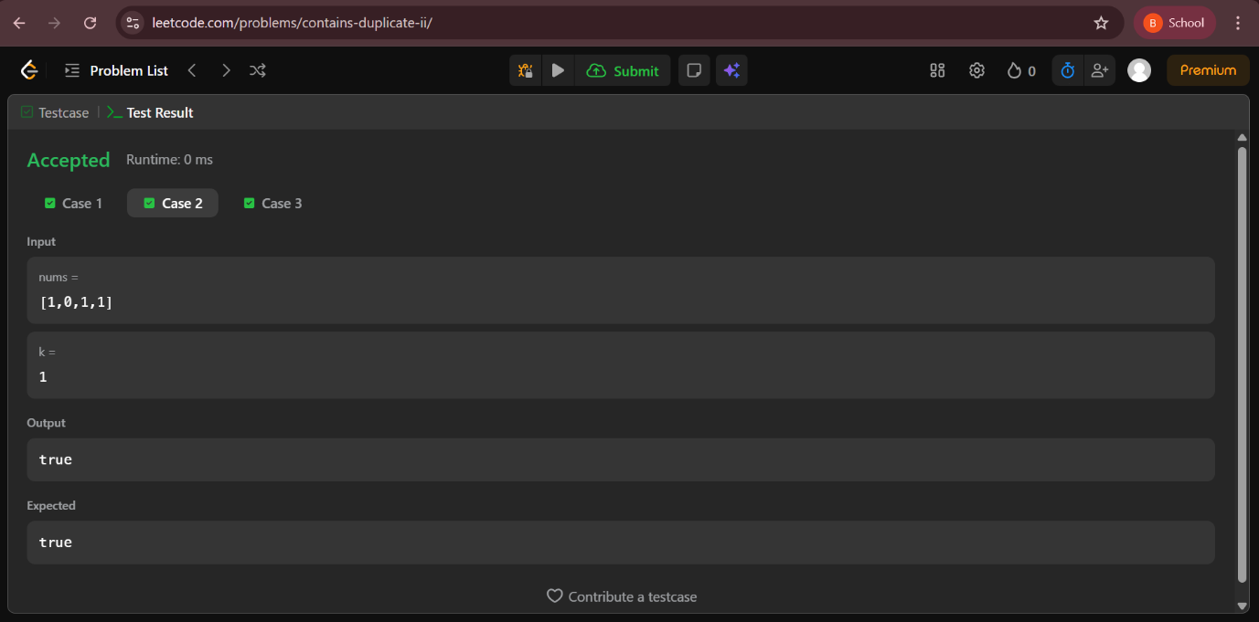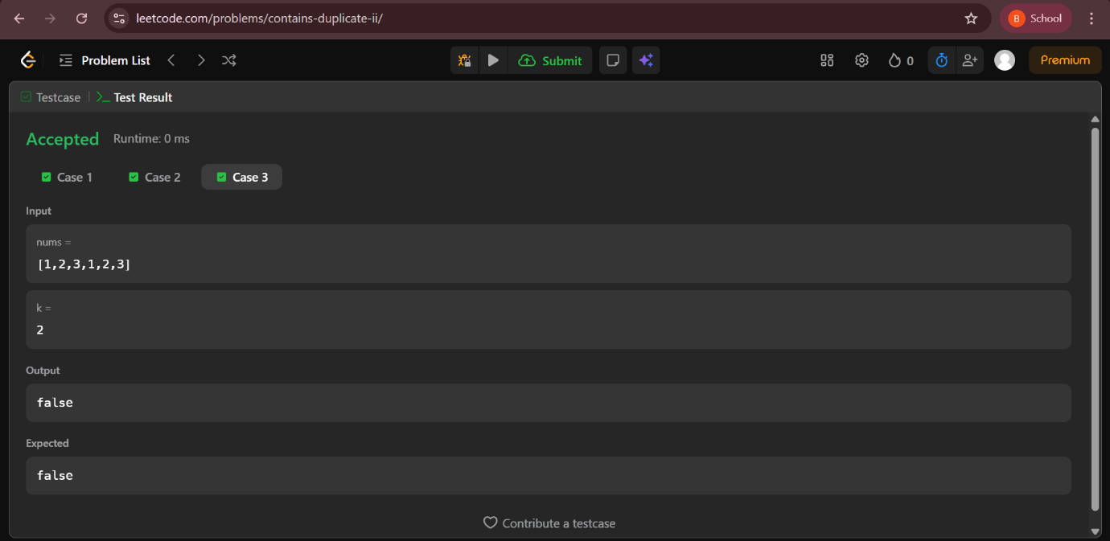

Task 3: Running Sum of 1D Array
Program:
import java.util.Arrays;
public class RunningSum {
public static void main(String[] args) {
int[] nums = {1, 2, 3, 4};
runningSum(nums);
System.out.println(Arrays.toString(nums));
}
static void runningSum(int[] nums) {
for (int i = 1; i < nums.length; i++) {
nums[i] += nums[i - 1];
}
}
}
Output: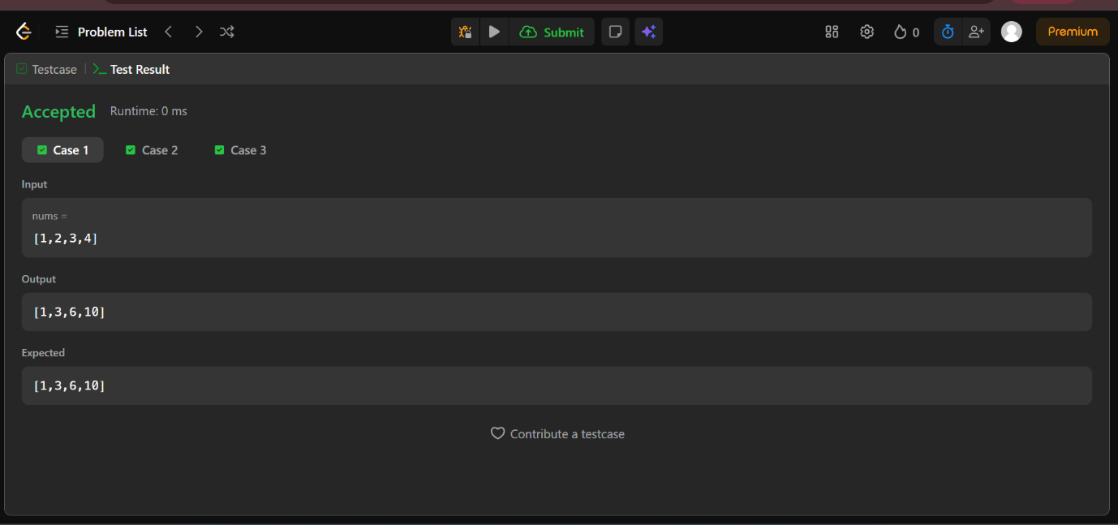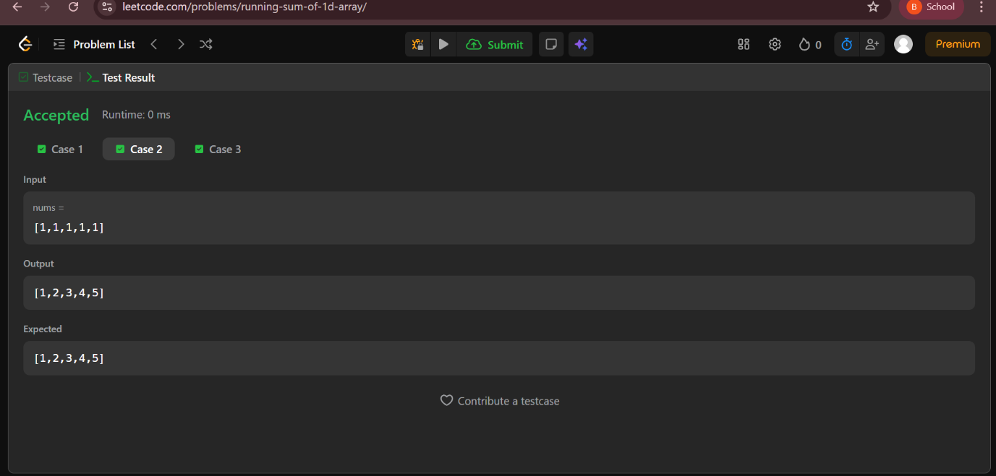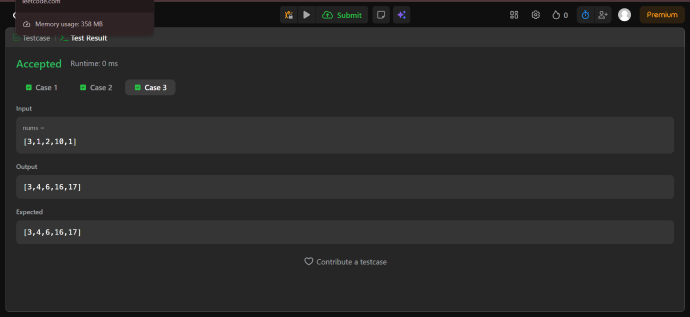

Task 4: Sum of Absolute Differences in a Sorted Array
Program:
import java.util.Arrays;
public class SumAbsoluteDifferences {
public static void main(String[] args) {
int[] nums = {1, 4, 6, 8, 10};
System.out.println(Arrays.toString(getSumAbsoluteDifferences(nums)));
}
static int[] getSumAbsoluteDifferences(int[] nums) {
int n = nums.length;
int[] res = new int[n];
int total = 0, left = 0;
for (int x : nums) total += x;
for (int i = 0; i < n; i++) {
int right = total - left - nums[i];
res[i] = nums[i] * i - left + right - nums[i] * (n - i - 1);
left += nums[i];
}
return res;
}
}

Output:
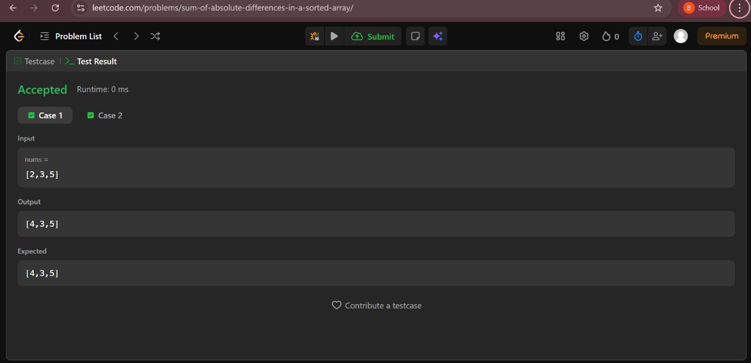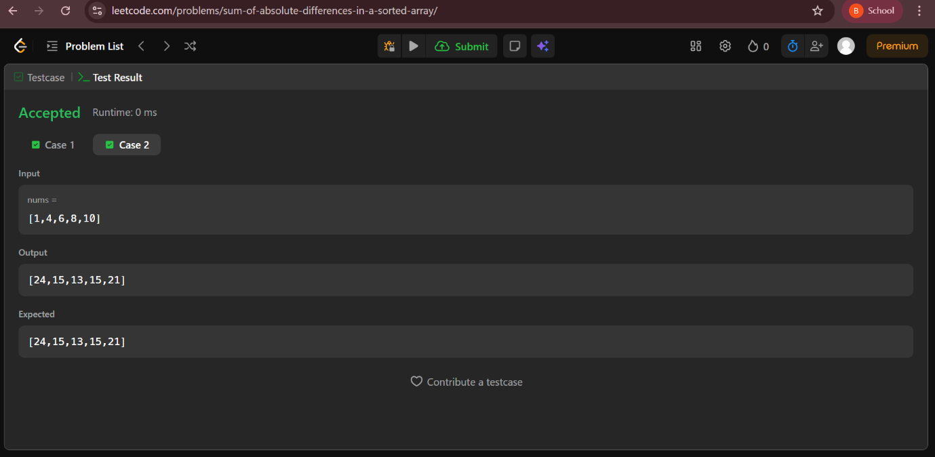

Task 5: Binary Search
Program:
public class BinarySearch {
public static void main(String[] args) {
int[] nums = {-1, 0, 3, 5, 9, 12};
int target = 9;
System.out.println(binarySearch(nums, target));
}
static int binarySearch(int[] nums, int target) {
int l = 0, r = nums.length - 1;
while (l <= r) {
int mid = (l + r) / 2;
if (nums[mid] == target) return mid;
else if (nums[mid] < target) l = mid + 1;
else r = mid - 1;
}
return -1;
}
}
Output: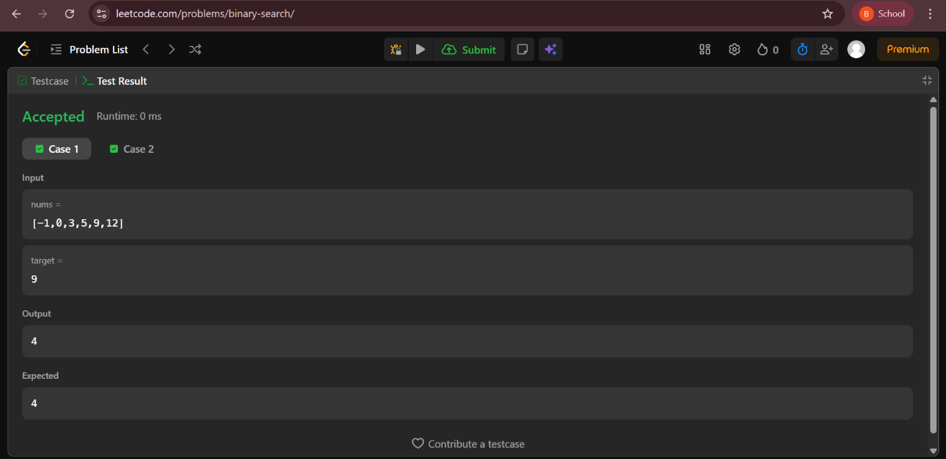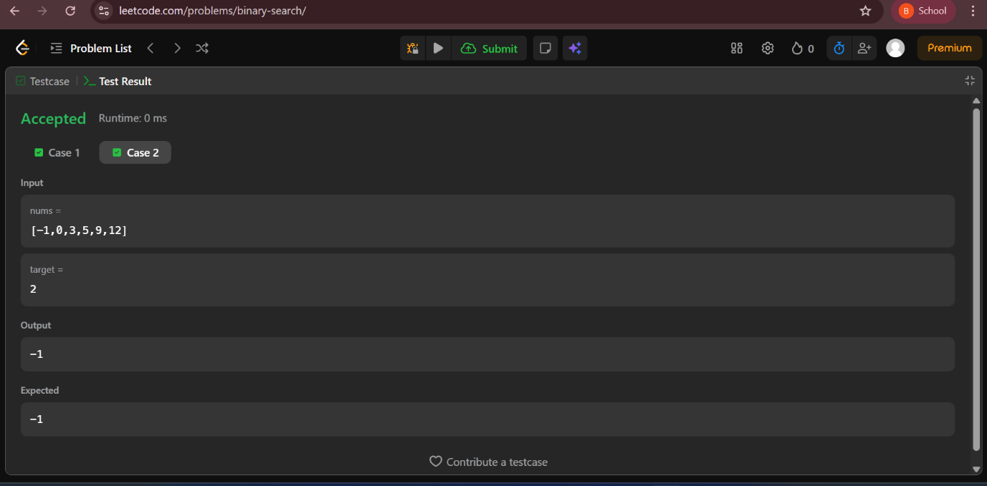

Task 6: Sort Colors
Program:
import java.util.Arrays;
public class SortColors {
public static void main(String[] args) {
int[] nums = {2, 0, 2, 1, 1, 0};
sortColors(nums);
System.out.println(Arrays.toString(nums));
}
static void sortColors(int[] nums) {
int low = 0, mid = 0, high = nums.length - 1;
while (mid <= high) {
if (nums[mid] == 0) swap(nums, low++, mid++);
else if (nums[mid] == 1) mid++;
else swap(nums, mid, high--);
}
}
static void swap(int[] a, int i, int j) {
int temp = a[i];
a[i] = a[j];
a[j] = temp;
}
}
Output:
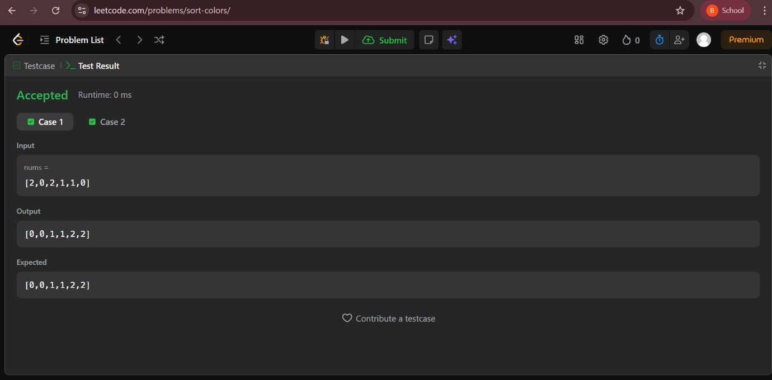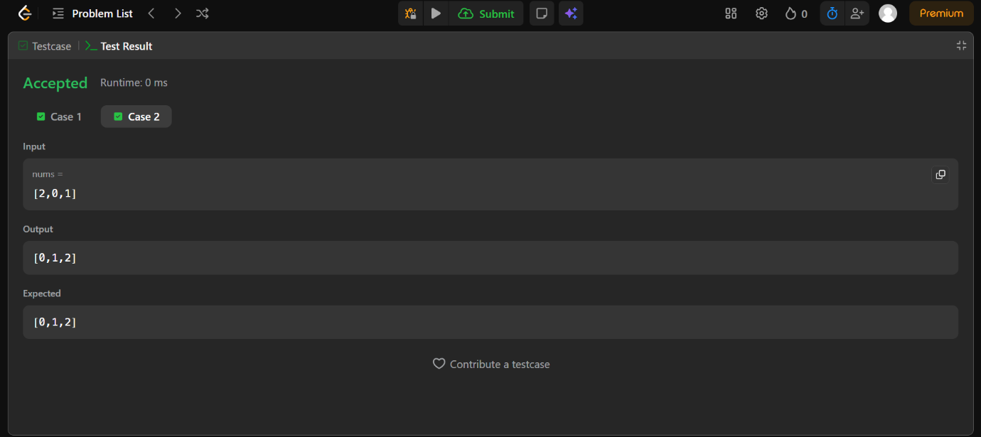

Task 7: Move Zeroes
Program:
import java.util.Arrays;
public class MoveZeroes {
public static void main(String[] args) {
int[] nums = {0, 1, 0, 3, 12};
moveZeroes(nums);
System.out.println(Arrays.toString(nums));
}
static void moveZeroes(int[] nums) {
int idx = 0;
for (int x : nums) {
if (x != 0) nums[idx++] = x;
}
while (idx < nums.length) nums[idx++] = 0;
}
}

Output: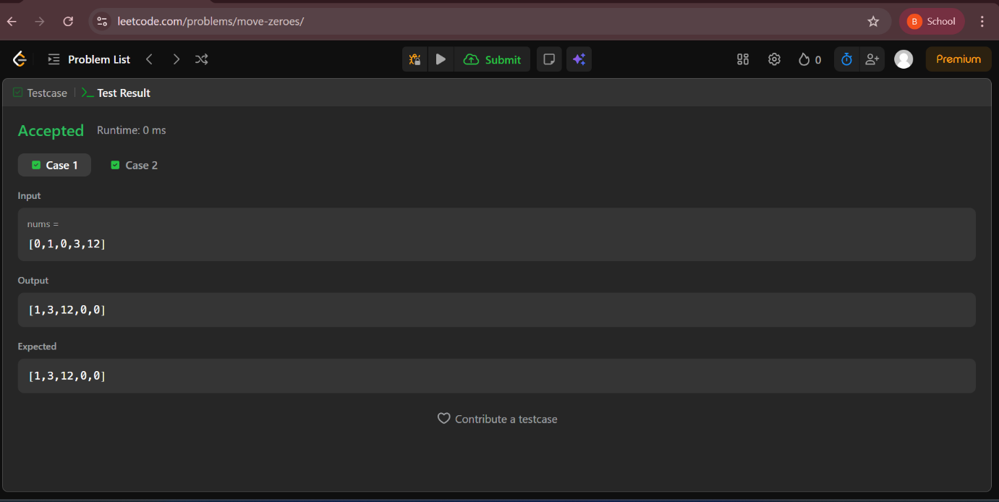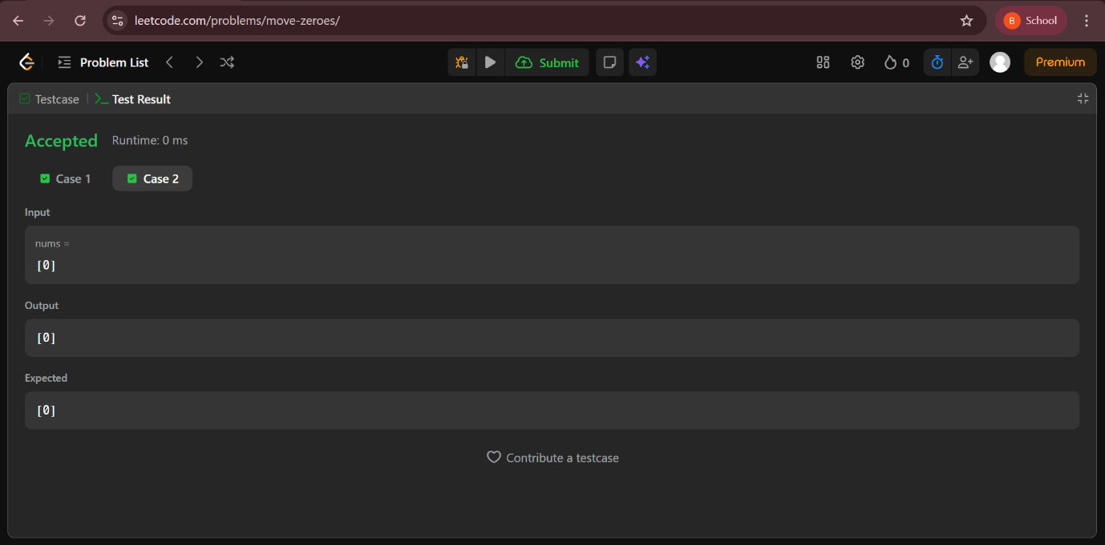

Task 8: Reverse String
Program:
import java.util.Arrays;
public class ReverseString {
public static void main(String[] args) {
char[] s = {'h','e','l','l','o'};
reverseString(s);
System.out.println(Arrays.toString(s));
}
static void reverseString(char[] s) {
int l = 0, r = s.length - 1;
while (l < r) {
char temp = s[l];
s[l++] = s[r];
s[r--] = temp;
}
}
}
Output: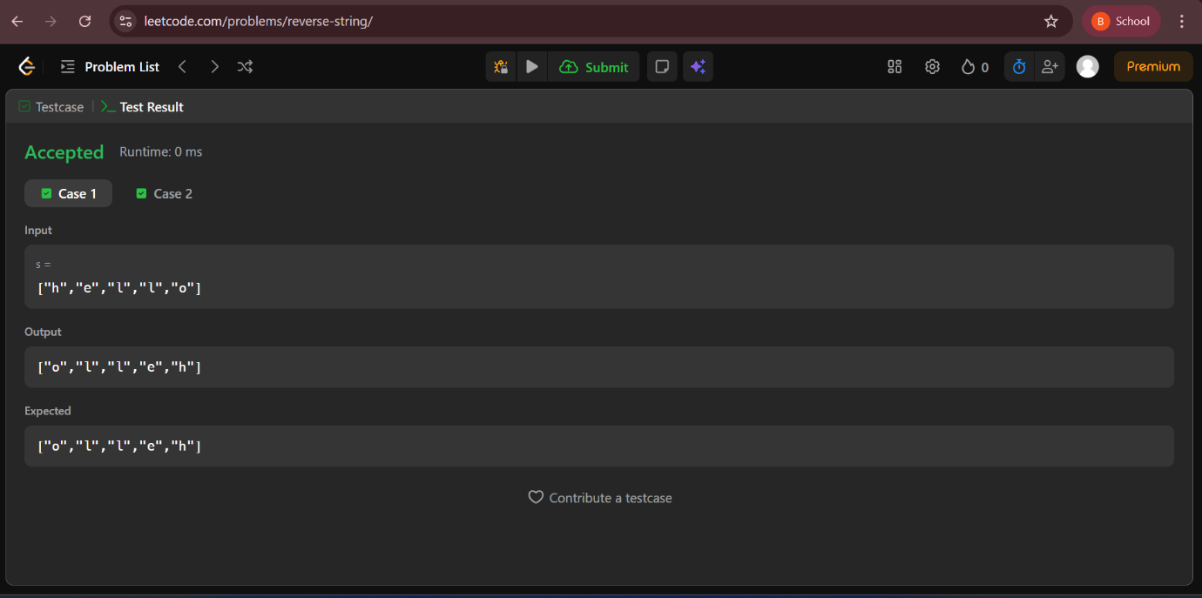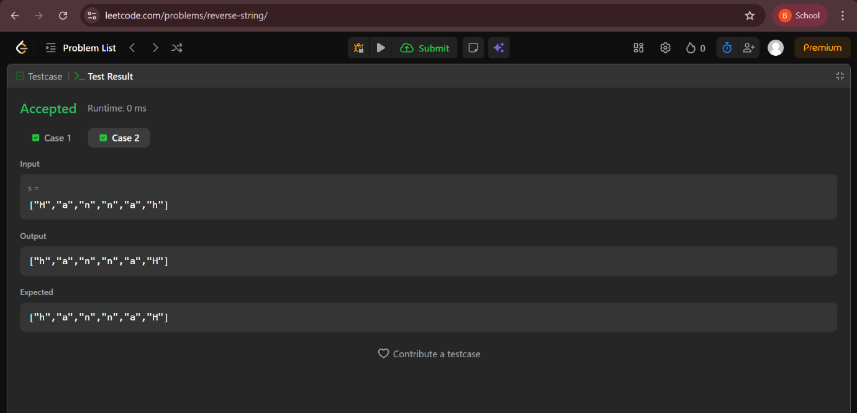

Task 9: Best Time to Buy and Sell Stock
Program:
public class BestTimeToBuySellStock {
public static void main(String[] args) {
int[] prices = {7,1,5,3,6,4};
System.out.println(maxProfit(prices));
}
static int maxProfit(int[] prices) {
int min = prices[0];
int profit = 0;
for (int i = 1; i < prices.length; i++) {
if (prices[i] < min) min = prices[i];
else profit = Math.max(profit, prices[i] - min);
}
return profit;
}
}
Output: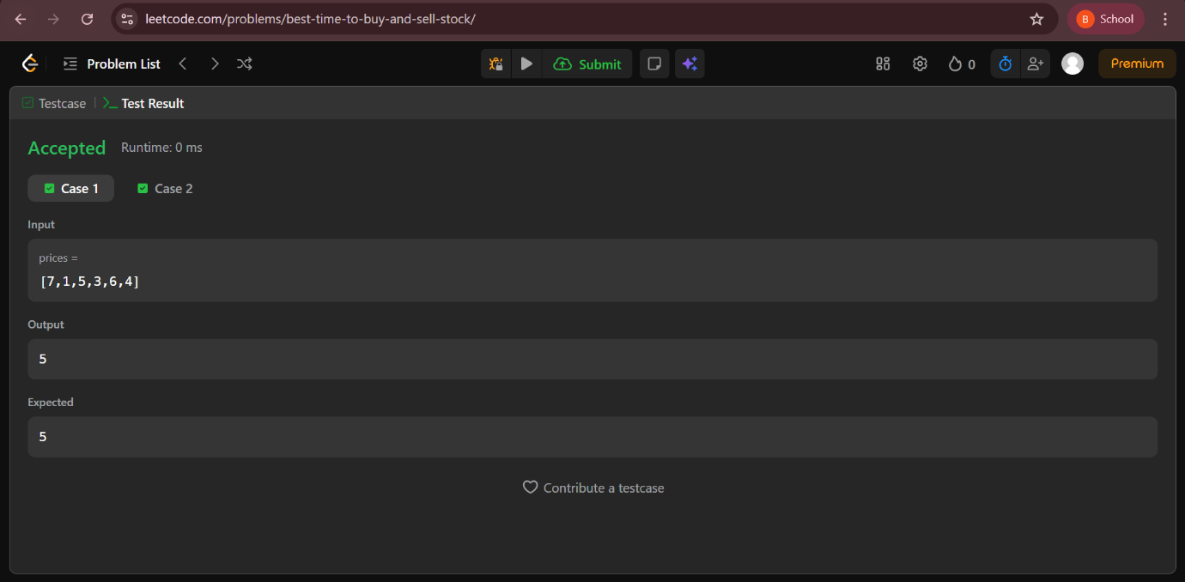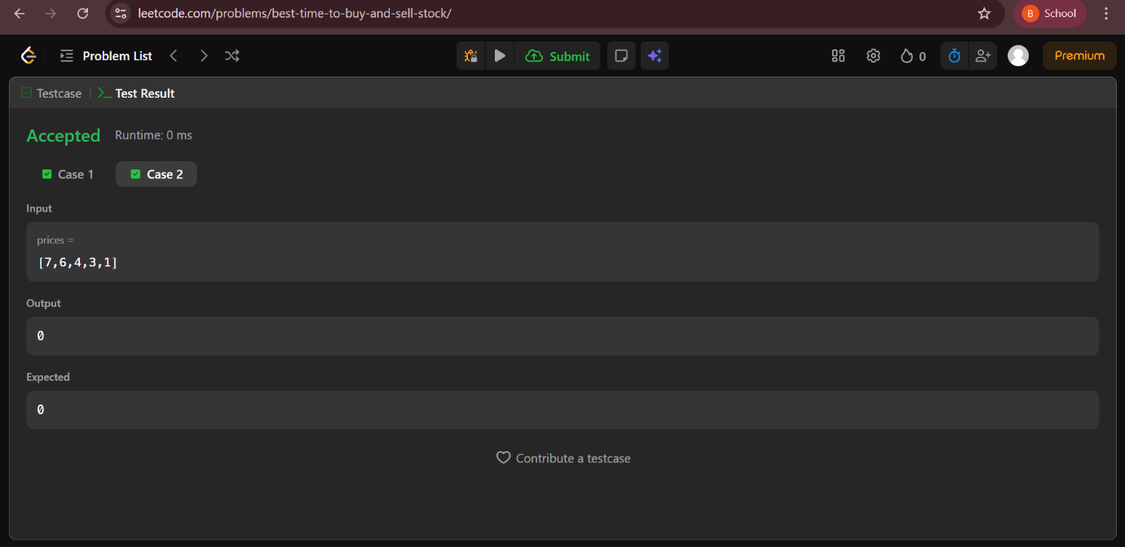

Task 10: First Unique Character in a String
Program:
class Solution {
public int firstUniqChar(String s) {
int[] count = new int[26];
// Count frequency of each character
for (int i = 0; i < s.length(); i++) {
count[s.charAt(i) - 'a']++;
}
// Find first character with frequency 1
for (int i = 0; i < s.length(); i++) {
if (count[s.charAt(i) - 'a'] == 1) {
return i;
}
return -1;
}
}
Output: